AI PROJECT ON GERMAN TRAFFIC SIGN DETECTION

PROJECT TEAM ID: PTID-AI-SEP22-1015

PROJECT ID : PRAICP-1002-TrafSignDetc

DATA COLLECTION:

* Data Collected form Rubixe For Educational Internship.

TASK: Object Detection

DATA INFORMATION:

* Total 4290 traffic sign images are present in 39 classes Each class contain 110 images
* Split data with the help of splitfolder library.
* 88 Images for training and 22 images for validation
* Create bounding boxes with the help of label-img tool and makesense.ai website

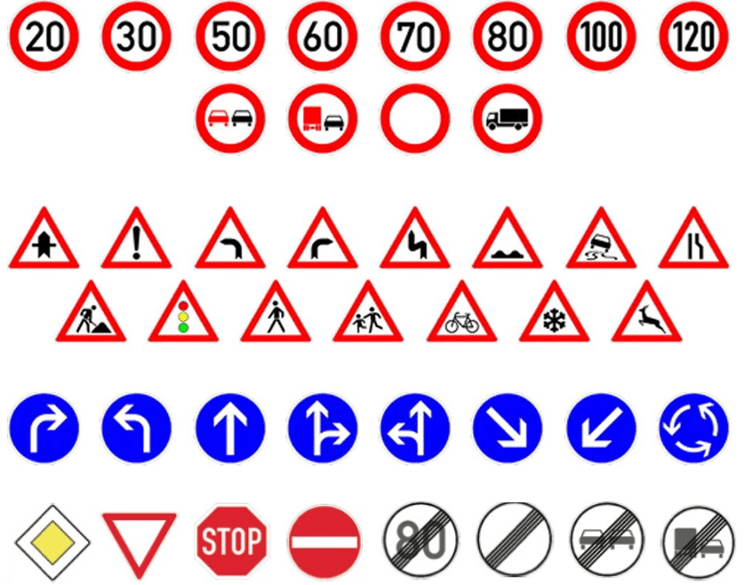

* To train a object detection model we are use google colab

DATA PREPRATION:

* Prepare folder structure that can be accept by YoloV5.
* Total 3438 images for training and 857 images for validation present in 39 classes.
* Create a bounding boxes with the help of label-img

And makesense.ai website according to YoloV5.

STEPS TO USE YOLOV5

* Cloning the YoloV5 file from official repository.
* Changing the directory of yolov5
* Installing the dependencies
* Download all versions pre-trained weights

STEPS BEFORE TRAINING CUSTOM DATASET:

1. Go to yolov5/data/
2. Open coco128.yaml
3. Edit the following inside it:

A. Training and Validation file path  
  
 B. Number of classes and Class names.

TRAINING YOLOV5 MODEL

* Set images size 128 with batch of 8
* Train model on 50 epochs
* Gives the data file path as well as give pre-trained weights path.

# VISUALISE THE TRAINING METRICS WITH THE HELP OF TENSORBOARD

AFTER TRAINING THE MODEL

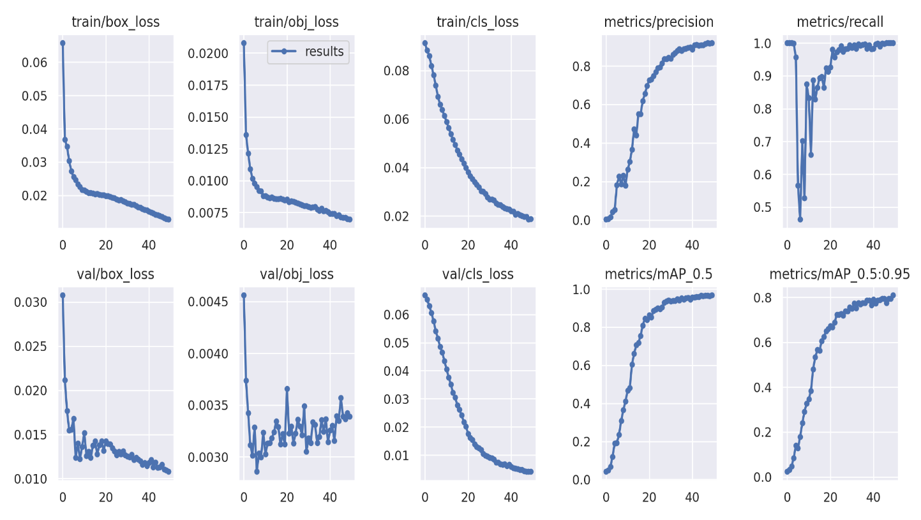

VALIDATION IMAGES PREDICTION:

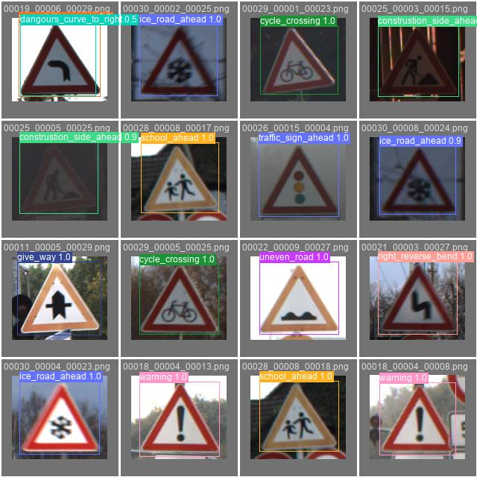

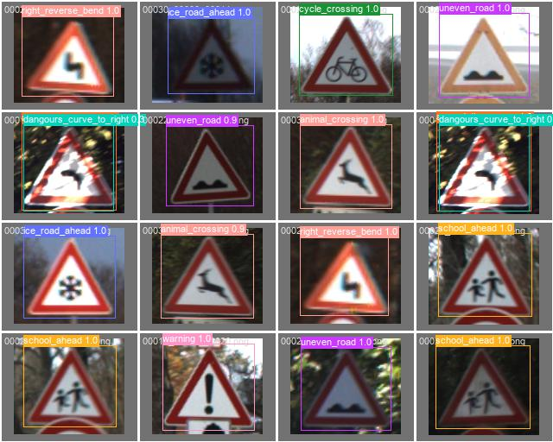

PREDICTED IMAGES:

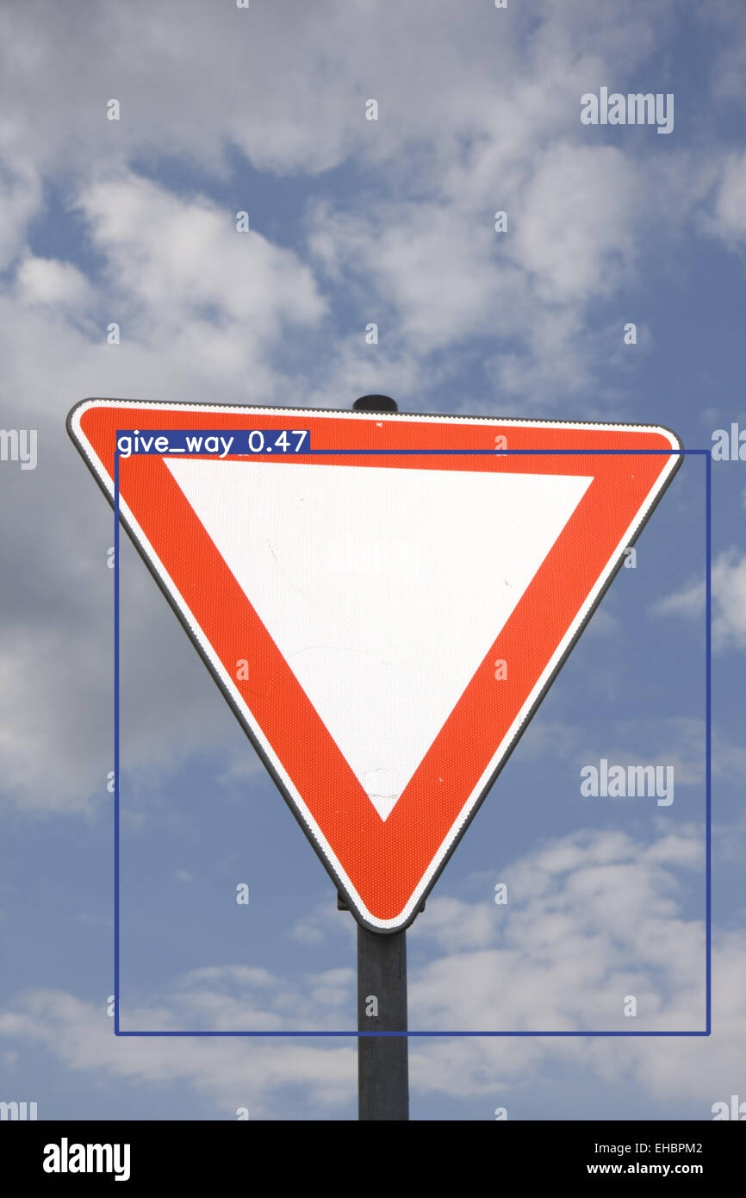

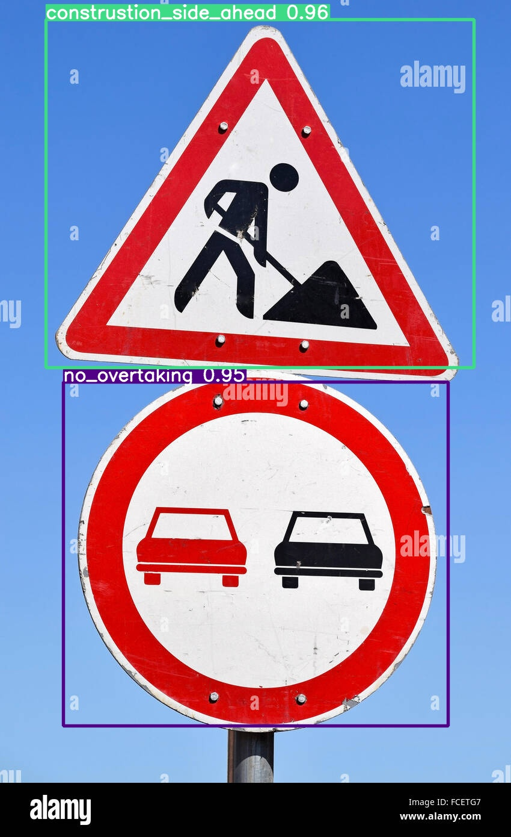

CHALLENGES FACED:

* Facing problem to understand the business case.
* challenge faced in bounding boxes creation
* Assign same no for all classes
* Made mistake in yolov5 folder structure
* Take lots of time to create bounding boxes

WHAT WE LEARN:

* Convert classification task to object detection to improve skill in object detection
* Understand the YoloV5 folder structure as well as learn label-img tool.
* Learn pytorch library.